Image | 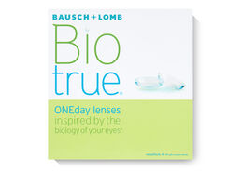
Brand | Bio true
Model No. | NIM567
Price | $629
PRODUCT DETAILS

