Image | 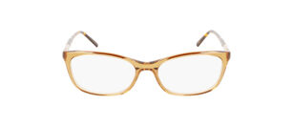
Brand | Dakely
Model No. | DAKYL77
Price | $799
PRODUCT DETAILS

