Image | 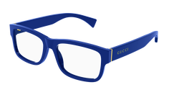
Brand | Gucci
Model No. | GG06340
Price | $619
PRODUCT DETAILS

