Image | 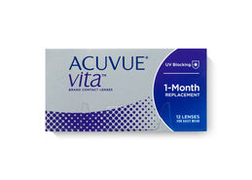
Brand | Acuvue
Model No. | NIM567
Price | $799
PRODUCT DETAILS

